

**DEDAN KIMATHI UNIVERSITY OF TECHNOLOGY**

**SCHOOL OF COMPUTER SCIENCE AND INFORMATION TECHNOLOGY**

**PROJECT DOCUMENTATION FOR FINAL YEAR IN:**

**BACHELOR OF SCIENCE IN BUSINESS INFORMATION TECHNOLOGY**

**BY:**

**NAME:** KIBOCHA MUTURI JOHN

**REGISTRATION NUMBER:** C027-01-0826/2020

**PROJECT TITLE:**

A COURT PROCEEDINGS MANAGEMENT SYSTEM

**SUPERVISOR**

**ELIZABETH MUTUA**

A project submitted to the Department of Information Technology in the School of Computer Science and Information Technology in partial fulfilment of the requirements for the award of the degree of Business in Information Technology at Dedan Kimathi University of Technology

**MARCH 2024**

# DECLARATION

I, KIBOCHA MUTURI JOHN, declare that this project is my original work and has not been presented for a degree in any other University.

Name: KIBOCHA MUTURI JOHN

Signature: ____________________

Date: ________________________

This project has been submitted for examination with my approval as University Supervisor.

Name: ELIZABETH MWAURA

Signature: __________________

Date: ______________________

# ABSTRACT

In Kenya, as in numerous parts of the world, efficient management of court proceedings is vital for ensuring timely justice delivery and upholding the rule of law. However, existing manual processes often lead to inefficiencies, delays, and challenges in coordinating legal activities, impacting both Kenyan citizens and the global perception of the country's legal system. Notwithstanding multiple efforts to tackle these concerns via Court Proceedings Management Systems (CPMS), present solutions demonstrate notable shortcomings, encompassing constrained flexibility, apprehensions regarding security, and insufficient integration with established legal frameworks.

This project aims to propose a comprehensive Court Proceedings Management System tailored to the specific needs of Kenyan clerks and users. By leveraging modern technologies, the proposed system seeks to address the shortcomings of existing CPMS and revolutionise the management of court proceedings in Kenya. Through a user-centric design approach and rigorous analysis of user requirements, the system aims to enhance efficiency, transparency, and accessibility in legal operations.

Addressing these challenges head-on has the potential to not only streamline court proceedings within Kenya but also serve as a model for other countries facing similar issues. Providing a robust and adaptable solution contributes to advancing legal technology globally and fostering trust and confidence in the Kenyan legal system.

TABLE OF CONTENTS

DECLARATION ii

ABSTRACT iii

CHAPTER ONE: INTRODUCTION 1

1.1 Background Information 1

1.2 Problem Statement 2

1.3 Objectives 2

1.3.1 General Objective 2

1.3.2 Specific Objectives 2

1.3 Justification 2

1.4 Scope 3

1.6 Limitation 4

CHAPTER TWO: LITERATURE REVIEW 5

2.1 Introduction 5

2.2 Case Studies 5

2.2.1 Case Study 1 – Clio.com 5

2.2.2 Case Study 2 – LawPracticeZA 6

2.2.3 Case Study 3 – Smart Lawyer Office 6

2.2.4 Case Study 4 – Smart Legal Counsel 7

2.3 Summary 8

2.3.1 Strengths of the system 8

2.3.2 Weaknesses of the system 9

2.3.3 Opportunities for the system 9

2.3.4 Threats to the system 10

2.4 Research Gap 11

2.5 Conclusion 12

CHAPTER THREE: PROPOSED METHODOLOGY 13

3.1 Introduction 13

3.2 Fact-Finding Techniques 13

3.2.1 Interviews 13

3.2.2 Questionnaires 13

3.2.3 Document Analysis 13

3.2.4 Observations 13

3.2.5 Prototyping 14

3.3 Software Design and Development Procedures 14

3.3.1 Requirements Analysis 14

3.3.2 System Architecture 14

3.3.3 Database Design 14

3.3.4 Development 14

3.3.5 Quality Assurance 15

3.3.6 Software Development Methods 15

3.3.7 Security Measures 16

3.3.8 User Interface Design 16

3.3.9 Documentation 16

3.3.10 Deployment 16

3.4 Preliminary Data Processing and Analysis 17

3.4.1 Data Collection 17

3.4.2 Data Cleansing 17

3.4.3 Data Integration 17

3.4.4 Data Analysis 17

3.4.5 User Feedback Incorporation 17

3.4.6 Security Assessment 17

CHAPTER FOUR: DATA COLLECTION AND ANALYSIS 18

4.1 Data Analysis 18

Figure 1: Role in the Court System 18

Figure 2: Experience in the Legal Field 19

Figure 3: Challenges Faced 19

Figure 4: Invoice Generation and Payment Processing 20

Figure 5: Issues with Current Payment Processing System 20

Figure 6: Tracking Progress of Court Cases 21

Figure 7: Feedback on the Online Payment System Proposal 21

Figure 8: Impact of Real-time Case Tracking and Dashboard Features 22

Figure 9: Overall Optimism about the Proposed System 23

4.2 Results 24

4.2.1 Efficiency of Current Processes 24

4.2.2 Challenges in Coordinating Court Proceedings 24

4.2.3 Views on the Proposed Online Payment Processing System 24

4.2.4 Impact of Real-time Case Tracking and Dashboard Features 24

4.2.5 Interest in Integration and Additional Training 24

4.2.6 Overall Optimism about the Proposed System 24

CHAPTER FIVE: SYSTEM ANALYSIS AND DESIGN 25

4.1 Introduction. 25

4.2 Requirement Analysis. 25

4.2.1 Functional Requirements 25

4.2.2 Non-functional Requirements 26

4.3 System Analysis 27

4.3.1 Use Case Diagram 28

4.3.2 Data Flow Diagram 29

4.3.3 Activity Diagram 31

4.3.4 Sequence Diagram 32

4.3.5 Entity Relationship Diagram 33

4.3.6 Class Diagram 34

CHAPTER SIX: IMPLEMENTATION AND TESTING 35

6.1 Introduction 35

6.2 Implementation Process 35

6.2.1 Database Management 35

6.2.2 Coding with Python 35

6.2.3 Agile Methodology 35

6.2.4 User-Centric Design 35

6.3 Key Aspects of Implementation 36

6.4 Testing 37

6.4.2 Testing Non-Functional Requirements 38

6.4.3 Testing System Verifiability 39

6.4.4 Testing System Validity 39

6.4.5 Testing System Authorization 39

6.4.6 Testing System Authentication 39

6.4.7 Testing System Responsiveness 40

6.5 Results 41

CHAPTER SEVEN: SYSTEM DOCUMENTATION 42

7.1 Introduction 42

7.1.1 Purpose of System Documentation 42

7.1.2 Structure of System Documentation 42

7.1.3 Audience 42

7.1.4 Importance of System Documentation 42

7.2 Glossary of Legal Terminology 43

7.2.1 Key Legal Terminology 43

7.3 System Documentation 43

7.3.1 Architecture Overview 43

7.3.2 Frontend Interface 43

7.3.3 Backend Server 44

7.3.4 Database Management System (DBMS) 44

7.3.5 API Integration 44

7.3.6 Modules 44

7.3.7 APIs 45

7.4 User Documentation 46

7.4.1 Introduction 46

7.4.2 User Guide 46

7.4.3 FAQ Section 46

7.4.4 Troubleshooting 46

7.5 Technical Documentation 46

7.5.1 Introduction 46

7.5.2 API Documentation 46

7.5.3 Database Structure 47

7.5.4 Development Environment Setup 47

7.6 User Manual 47

7.6.1 Overview 47

7.6.2 Getting Started 47

7.6.3 System Navigation 47

7.6.4 Core Functionality 47

7.6.5 Advanced Features 48

7.6.6 Troubleshooting and Support 48

7.6.7 Conclusion 48

REFERENCES 49

APPENDICES 51

APPENDIX A: SAMPLE QUESTIONAER 51

APPENDIX B: GANTT CHART 55

APPENDIX C: BUDGET 56

**LIST OF FIGURES**

Figure 1: Agile Method Diagram 15

Figure 2: Role in the Court System 18

Figure 3: Experience in the Legal Field 19

Figure 4: Challenges Faced 19

Figure 5: Invoice Generation and Payment Processing 20

Figure 6: Issues with Current Payment Processing System 20

Figure 7: Tracking Progress of Court Cases 21

Figure 8: Feedback on the Proposed Online Payment Processing System 21

Figure 9: Impact of Real-time Case Tracking and Dashboard Features 22

Figure 10: Overall Optimism about the Proposed System 23

Figure 11: Use Case Diagram 28

Figure 12: Dataflow Diagram 29

Figure 13: Activity Diagram 31

Figure 14: Sequence Diagram 32

Figure 15: Entity Relationship Diagram 33

Figure 16: Class Diagram 34

Figure 17: Testing Functional Requirements Image 38

Figure 18: Testing System Authentication Image 40

Figure 19: Testing System Responsiveness Image 41

Figure 20: Gantt Chart 55

**LIST OF TABLES**

Table 1: Case Studies Comparison 12

Table 2: Testing Functional Requirements Results 37

Table 3: Testing Non-Functional Requirements Results 38

Table 4: Testing System Verifiability Results 39

Table 5: Testing System Validity Results 39

Table 6: Testing System Authorization Results 39

Table 7: Testing System Authentication Results 39

Table 8: Testing System Responsiveness Results 40

Table 9: Budget 56

# CHAPTER ONE: INTRODUCTION

## 1.1 Background Information

Court proceedings and their payments are essential components of the legal system, as they determine the outcomes and consequences of cases. This task is complex, encompassing multiple factors, including case types, jurisdictions, regulations, procedures, data, and invoices. These factors pose different challenges for court clerks, who handle court proceedings and their payments efficiently and effectively. In this project, I aim to address these challenges by developing a web-based Court Proceedings Management System to address these challenges.

One of the main challenges faced by clerks is the complexity of court proceedings, especially when they involve multiple jurisdictions. For example, a clerk may have to address a case that involves a multinational corporation accused of tax evasion in several countries. Such a case would require the clerk to coordinate with different legal authorities, follow different regulations, and manage different data sources. This can lead to data fragmentation and inconsistencies, which can affect the accuracy and reliability of the case outcome (Smith & Johnson, 2019).

The inefficiency of invoice generation and payment processing is a significant problem in Kenya's legal space. For example, a clerk may have to issue an invoice to an individual who has been fined for a traffic violation. The invoice generation process requires that the clerk keys in the court proceedings they entered manually to the system and then generate invoices from the judgement before the invoice is generated. Once the invoice is generated, the payment processing may involve cash transactions, receipts, and records. The receipts and records must be transcribed into the system to fulfil accounting requirements. These processes are slow and cumbersome for both the clerk and the individual, who may have to await prolonged periods or visit multiple offices. In addition, these methods are prone to errors and instances of fraud, which can jeopardise the transparency and accountability of the outcome of the case (Brown et al., 2020).

To address these challenges, I have developed a web-based Court Proceedings Management System that comprehends and addresses the needs of clerks in managing court proceedings and their payments. The system has four key features: efficient court proceedings management, streamlined invoice generation, transparent payment tracking, and data-driven proceedings outcome reporting, according to Garcia (2017).

By providing an integrative platform that fosters efficiency, transparency, and convenience, the system positions itself as an innovative solution for the legal system in Kenya (Smith & Johnson, 2019).

## 1.2 Problem Statement

Court proceedings and payments are crucial for the legal system, involving factors like case types, jurisdictions, regulations, procedures, data, and invoices. These factors pose challenges for court clerks and users who handle these processes efficiently. This project aims to address these challenges by developing a web-based system that automates court proceedings and payments for legal clerks and users.

One challenge is the lack of a user and clerk registration system, limiting access to relevant information and services. This lack of registration also poses risks for data security and privacy. Another challenge is the decentralised invoice generation and payment processing, which can be slow and cumbersome for both clerks and users. These processes are prone to errors and frauds, compromising transparency and accountability of case outcomes.

Clerks and users also face difficulties in tracking their cases and payments, as they lack access to real-time updates and insights. They rely on phone calls or court visits, which can be inconvenient and stressful. These methods may not provide accurate or consistent information, affecting the trust and satisfaction of clerks and users.

These challenges align with the broader legal framework in Kenya, emphasising the importance of a thorough examination and resolution of these matters. This system is the natural and strategic response to transform legal practice for clerks and users.

## 1.3 Objectives

### 1.3.1 General Objective

To develop a web-based system that automates court proceedings and payments for legal clerks.

### 1.3.2 Specific Objectives

By the end of this project, the system should be able:

1. To enable users' and clerks' registration.
2. To allow clerks to capture court proceedings.
3. To generate invoices for case payment.
4. To enable users to make payments.
5. To enable users to track cases.

## Justification

The rationale behind developing a web-based system to automate court proceedings and payments for legal clerks and users in Kenya stems from the pressing challenges faced within the country's legal framework. A primary goal of this initiative is the establishment of a registration system for users and clerks, aimed at enhancing the accessibility and security of information and services. This entails enabling individuals to create personalised accounts on the platform, manage their details, monitor case history and payment status, and adjust preferences. To uphold data privacy, the system will employ password or biometric authentication for user and clerk verification, simplifying registration procedures and enhancing user experience (Smith & Johnson, 2019).

The project seeks to implement automation in court proceedings to reinforce the efficiency and accuracy of case management. By providing clerks with a unified interface to access case information from various sources and jurisdictions, the system mitigates data fragmentation and inconsistencies. This integrated approach fosters smoother coordination and communication among legal authorities, ultimately enhancing the reliability of case outcomes (Brown et al., 2020).

Likewise, the system aims to facilitate online payment processing for fines and fees associated with cases, to streamline the payment process, and enhancing transparency and accountability. Users will have the convenience of viewing electronic invoices via QR codes or email, eliminating the need for paper forms and stamps. They can make payments online using mobile money or credit cards, reducing processing time and improving overall efficiency (Brown et al., 2020).

These objectives not only benefit clerks but also hold significance for the broader legal system in Kenya. Addressing these challenges comprehensively is crucial, and the system represents an innovative solution poised to revolutionise legal practice by automating court proceedings and payments for both clerks and users.

## Scope

The establishment of the system's boundaries and objectives is of utmost importance. The project aims to automate the operational processes of clerks, improving efficiency and service delivery. Its functionalities include user and clerk registration, court proceedings automation, online payment processing, and case tracking. These features collectively address clerks' operational needs, offering conveniences such as online fine payment options and real-time case tracking, which improve transparency and trust in the legal process.

Originally designed for the Kenyan legal system, the system's capabilities transcend geographical limitations, accommodating various legal environments. One such example is its capability to handle cases involving multiple jurisdictions, demonstrating its suitability in various legal scenarios. This broader scope enhances its potential impact and utility across different legal domains, facilitating smoother operations and better service delivery.

The primary beneficiaries of the system are legal professionals, paralegals, administrative staff, and clients within the legal field. The customised features cater to their specific needs and preferences, providing tools such as data analysis and reporting to facilitate well-informed decision-making. By streamlining court proceedings and payment processes, the system endeavours to transform the management of legal operations, with the goal of enhancing efficiency, accuracy, and trust in the legal system.

## 1.6 Limitation

Providing an honest assessment of the system's capabilities and limitations is of utmost importance in its development. These limitations, while not intended to undermine the system's significance, provide a transparent overview of its functionalities and considerations.

One limitation of the system is that it requires a stable internet connection to function properly. Implementing internet connectivity facilitates important functionalities, such as user and clerk registration, automation of court proceedings, online payment processing, and case tracking and dashboard (Williams, 2006). Consequently, individuals living in areas with unreliable or non-existent internet access may experience restricted functionality or encounter errors.

The system may vary in compatibility across different operating systems and devices. While efforts have been made to ensure broad compatibility, variations in performance and user experience may differ based on users' chosen hardware and software environments (Blanchard & Fabrycky, 1998). For example, some features may not work well on older or unsupported browsers or devices.

It lacks built-in integration capabilities with third-party applications. Despite its ability to automate court proceedings and payments, incorporating external software tools may require further development and customisation. As an illustration, certain users might desire to integrate the system with their current accounting or legal software, necessitating further programming or configuration.

Finally, the system is influenced by the challenges encountered during the study, which may have shaped the prioritisation and implementation of certain features. These challenges, such as resource constraints, time limitations, and the ever-evolving technology landscape, may have affected the design and functionality of the system. For Instance, certain features might have been simplified or excluded owing to time constraints or limited resources.

It is essential to emphasise that the system will undergo rigorous development to ensure reliability and performance (Williams, 2006). However, recognising these inherent limitations and challenges is a fundamental aspect of software development projects. Despite these constraints, the system represents a significant advancement in addressing critical issues within the legal system and offers valuable functionalities to its users.

# CHAPTER TWO: LITERATURE REVIEW

## 2.1 Introduction

By synthesising and analysing scholarly works, this review aims to shed light on the need for conducting case studies within the realm of legal technology, specifically focusing on the objectives and relevance of these case studies in the system. The overarching goal of this literature review is to explore the multifaceted dimensions of Court Proceedings Management Systems, discern their challenges, and unearth the potential benefits they offer to legal practitioners.

Through this exploration, I aim to acquire a holistic understanding of the dynamics shaping the legal technology landscape, paving the way for an informed and insightful investigation into the court proceedings management system.

## 2.2 Case Studies

### 2.2.1 Case Study 1 – Clio.com

Clio.com is a cloud-based software designed to assist lawyers in managing cases, clients, documents, billing, and other tasks across multiple devices. Nevertheless, a thorough examination of the literature with project objectives and challenges reveals that Clio.com only satisfies certain criteria for digitising court case payments in Kenya to a limited extent.

Although it provides features such as online court invoice generation and payment, case tracking, and dashboards, it does not fully support user and clerk registration or automate court proceedings. The absence of authentication measures creates vulnerabilities that could compromise the security and privacy of data. Additionally, it cannot automate certain components of court proceedings, such as the entry of case information or the delegation of tasks.

Thus, while Clio.com employs a user-cantered approach and agile software development methods, it falls short in meeting the specific needs of court clerks and addressing certain limitations. To address these issues, suggested improvements include enhancing authentication mechanisms, automating more aspects of court proceedings, and conducting further user research. These enhancements would provide a more tailored solution for digitising court case payments, particularly in Kenya.

The proposed system aims to address these gaps by offering comprehensive features such as user and clerk registration with robust authentication, automation of court proceedings, online invoice generation and payments, and real-time case tracking. Extensive user research and testing will ensure alignment with the needs of users and clerks in Kenya, while cloud computing technologies will ensure scalability, reliability, and security. By adhering to ethical and legal standards, the proposed system aims to provide a superior solution for digitising court case payments compared to existing systems like Clio.com.

### 2.2.2 Case Study 2 – LawPracticeZA

Legal technology solutions, like LawPracticeZA, cater to regional legal needs and have acquired significant attention lately (Smith & Johnson, 2019). Developed by ajs.co.za, LawPracticeZA is tailored to meet the requirements of legal practitioners in South Africa and Botswana, offering web-based services that integrate billing, matter management, and accounting functionalities (AJS, n.d.).

Despite its features, such as online invoicing and case tracking, LawPracticeZA falls short of fully supporting user registration and court proceedings automation for digitising court case payment in Kenya (Turner & White, 2018). Users can only register as lawyers or staff members, limiting their access to case information and payment options (Turner & White, 2018). LawPracticeZA lacks document generation and evidence management for court proceedings, requiring clerks to rely on manual methods (Robinson, 2020).

Ajs.co.za adopts a collaborative development approach involving local legal professionals to keep LawPracticeZA relevant and effective within its regional context (Robinson, 2020). However, this approach presents challenges, such as ensuring compatibility with other legal systems in the region (Robinson, 2020).

This case study underscores the importance of regional Court Proceedings Management Systems tailored to the unique needs of legal practitioners (Smith & Johnson, 2019). It suggests improvements for LawPracticeZA, including enabling client sign-ups, document generation, and conducting user research for customisation (Smith & Johnson, 2019). The proposed system aims to address these gaps and digitise court case payment in Kenya.

### 2.2.3 Case Study 3 – Smart Lawyer Office

In recent years, there has been a growing trend in Kenya towards adopting Court Proceedings Management Systems tailored to the local legal landscape (Smith & Johnson, 2019). One such system, Smart Lawyer Office, aids lawyers in various tasks like case management and billing, specifically designed for Kenya's legal requirements.

However, upon comparing existing literature with project goals, it's evident that Smart Lawyer Office only partially fulfils the needs for digitising court case payments in Kenya. While it allows online generation of court invoices and case tracking, it lacks user and clerk registration and court proceedings automation (Turner & White, 2018).

The absence of features, such as voice document generation and evidence management, requires clerks to rely on manual methods (Robinson, 2020). Consequently, it has not proven entirely suitable for achieving project objectives due to these constraints.

The software provider employs a collaborative development approach involving local legal experts, ensuring relevance within Kenya. Yet, this poses challenges in ensuring compatibility with other legal systems (Robinson, 2020).

Future research should focus on assessing the long-term impact of Smart Lawyer Office adoption on Kenyan law firms' productivity and profitability. Ethical considerations, like data privacy and security within Kenya, also require further investigation. User experience studies across diverse legal contexts are essential.

Future research should also assess Smart Lawyer Office's scalability for different-sized law firms, adaptability to varied legal environments, and data security measures within the local context. These efforts would bridge existing research gaps and enhance understanding of Smart Lawyer Office's potential in Kenya.

This case study emphasises the importance of localised Court Proceedings Management Systems in meeting the needs of legal practitioners within specific geographic contexts. It serves as a foundation for further investigations into enhancing legal practice efficiency.

### 2.2.4 Case Study 4 – Smart Legal Counsel

Smart Legal Counsel, a local legal practice management software, significantly aids corporate legal counsels and departments in Kenya by handling case management, documents, billing, and other crucial tasks tailored to the local legal context. However, in digitising court case payments, it only partially fulfils requirements. Although it enables online court invoicing and payments, case tracking, and dashboards, it lacks full support for user and clerk registration and court proceedings automation. For instance, users can only sign up as corporate legal counsels or staff, limiting access to case information and payment options (Turner & White, 2018).

Smart Legal Counsel lacks document generation and evidence management features for court proceedings, requiring clerks to resort to manual methods (Robinson, 2020). Hence, it does not align entirely with the project goals due to existing limitations. The software development approach involves collaboration with local legal experts, ensuring relevance in the Kenyan context. However, challenges arise, particularly in ensuring compatibility with other legal systems.

While literature provides insights into functionalities and localised design, there are research gaps, including the long-term impact of Smart Legal Counsel adoption on corporate legal operations in Kenya and ethical considerations like data privacy (Robinson, 2020). Future research should focus on assessing scalability, adaptability to various corporate legal environments, and data security measures. These efforts aim to address research gaps and provide a comprehensive understanding of Smart Legal Counsel's potential in Kenya, setting the stage for in-depth investigations into enhancing corporate legal efficiency (Turner & White, 2018).

## 2.3 Summary

The literature review has yielded valuable insights into Court Proceedings Management Systems, highlighting their importance in the legal field. Four case studies, namely Clio.com, LawPracticeZA, Smart Lawyer Office, and Smart Legal Counsel, were examined, revealing strengths, weaknesses, and research gaps.

Clio.com, a global legal practice management software, showcased features like third-party integration and workflow automation. However, gaps exist in understanding implementation challenges and ethical implications. Similarly, LawPracticeZA and Smart Lawyer Office, tailored for South Africa, Botswana, and Kenya respectively, showed promise but lacked comprehensive long-term impact assessments and regional-specific ethical considerations. Smart Legal Counsel, designed for corporate legal departments in Kenya, exhibited potential, but also shared similar research gaps.

These findings underscore the need for further research to address shortcomings such as limited depth in existing studies, long-term impacts, data security, privacy, scalability, and adaptability. They serve as a basis for future investigations to advance legal technology in Kenya.

### 2.3.1 Strengths of the system

Acknowledging the strengths and distinctive advantages of the system, particularly in relation to court operations in Kenya, is essential. This perspective allows us to appreciate the system beyond its highlighted weaknesses in existing reviews.

A key strength of the system lies in its customisation to meet specific needs. The system is intricately tailored to align with the specific requirements of clerks and users in Kenya, ensuring seamless integration with their workflows and demands. This customisation is a testament to the system's adaptability and user-centric design.

Building on this adaptability, the system boasts efficient user and clerk registration. It facilitates online access for users to their case details and payment options. Simultaneously, it allows clerks to manage their profiles and securely track previous cases. This dual functionality underscores the system's commitment to efficiency and security.

The system further excels in the automation of court proceedings. This feature minimises errors, document misplacement, and update delays for clerks, enhancing productivity. The automation of these processes indicates the system's drive towards modernisation and efficiency.

Besides automation, the system provides transparent case tracking. Real-time updates and insights offered through the system's dashboard foster transparency and trust among clerks and users. This transparency not only facilitates easier case monitoring but also strengthens the relationship between clerks and users.

The system stands out in its ability to generate data-driven reports. By producing data-backed case outcome reports, it empowers clerks to offer strategic legal counsel based on historical data. This data-driven approach is a testament to the system's commitment to informed decision-making.

In the realm of financial transactions, the system offers online invoicing and payments. This feature provides an online platform for generating court invoices and making payments. It meets modern user preferences for convenience and security while reducing administrative burdens. This digital approach to financial transactions showcases the system's commitment to meeting user needs in a modern context.

Collectively, these strengths position the system as a solution that is both viable and transformative. This solution is customised to meet the diverse needs of both clerks and users in Kenya.

### 2.3.2 Weaknesses of the system

In contrast to the system's identified strengths, it's crucial to recognise its weaknesses and limitations. A key feature that emerges as a critical weakness is the integration challenges. The system may struggle to integrate with existing legal platforms like court databases and payment gateways, risking data consistency and integrity.

Ethical and legal issues come to the forefront. Ethical dilemmas may arise concerning data privacy and security, necessitating compliance with relevant laws like Kenya's Data Protection Act of 2019, and the implementation of encryption and access control measures.

The system stands out in its potential to face user resistance or reluctance. Some users may resist adopting the system due to familiarity with traditional methods, requiring education, feedback mechanisms, and addressing concerns like trust and cost.

However, the system's AI-powered features may be limited in accurately predicting case outcomes and tracking client cases, potentially influencing user decisions, and facing ethical implications. This limitation is a significant area for improvement.

Furthermore, scalability presents a significant challenge. Adapting the system to different regions might require customisation to accommodate diverse legal landscapes and address specific regional obstacles, such as internet accessibility.

These weaknesses underscore areas for improvement to realise the system's full potential. Further exploration will detail how the system plans to address these weaknesses and capitalise on its strengths to provide a comprehensive legal management solution for Kenyan clerks and users.

### 2.3.3 Opportunities for the system

A key feature of the system is its potential to tap into the growing demand for legal technology. The system is well-positioned to benefit from this rising demand, particularly in Kenya's digitally transforming legal sector. This trend creates a favourable market environment, as court clerks and users seek efficient ways to manage proceedings and payments (Smith & Johnson, 2019).

Furthermore, the system can acquire a competitive edge by offering a comprehensive solution tailored to the specific needs of Kenyan clerks and users. The utilisation of AI capabilities like case prediction and tracking distinguishes it from other systems (Brown et al., 2020).

The system stands out further through its potential for collaboration. Integration with other legal stakeholders' systems could enhance the system's functionality and foster cooperation among legal actors (Robinson, 2020).

Moreover, the system has significant innovation potential. Incorporating innovative technologies can help the system adapt to evolving user needs and address challenges in the legal landscape (Garcia, 2017).

Finally, the system has the potential to create a significant social influence. Through enhancing the effectiveness and accountability of court procedures and financial transactions, the system has the potential to enhance access to justice and uphold the rule of law in Kenya (Turner & White, 2018).

These opportunities highlight areas where the system can leverage its strengths and address weaknesses. Further exploration will detail how the system plans to seize these opportunities and mitigate threats to provide a comprehensive legal management solution for Kenyan clerks and users.

### 2.3.4 Threats to the system

Recognising potential threats and challenges is crucial for the Court Proceedings Management System's success. A key feature of these external factors is that they may impede its functionality or performance.

Moreover, the system might encounter technical issues such as bugs, errors, or failures, affecting its reliability and security. Regular monitoring and maintenance are essential to ensure smooth operation and user satisfaction.

The system stands out in its compliance with legal regulations. Adherence to data protection, tax, and payment laws is imperative. Failure to adhere to these regulations could result in legal liabilities or penalties.

Faced with competitive pressure from similar systems, continuous innovation is necessary to maintain a competitive edge. This is further enhanced by adapting to evolving user demands, which require feedback, testing, and customisation to enhance user satisfaction.

Overcoming cultural barriers is another significant aspect. Language differences and trust issues can be addressed through localisation and user education, which are crucial for adoption.

These challenges underscore the need for preparedness and caution. As we delve further, strategies to mitigate these challenges and capitalise on opportunities will be explored. This approach ensures the system's success and its ability to meet the needs of its users effectively.

## 2.4 Research Gap

The literature review underscores the significance of Court Proceedings Management Systems (CPMS) while illuminating critical research gaps. These gaps necessitate further investigation to enrich comprehension of legal technology's potential.

A key feature of these gaps is the long-term impact assessment. Current literature offers limited insights into the enduring effects of CPMS adoption on court proceedings' efficiency, transparency, and payment convenience. A comprehensive study is imperative to assess sustained benefits and drawbacks.

Expanding upon this gap gives rise to ethical and legal ramifications. While data security concerns are briefly acknowledged, there is a lack of comprehensive examination of the ethical and legal implications, particularly within the Kenyan context. The examination of matters pertaining to data ownership and adherence to evolving regulations is of utmost importance.

The system stands out in its user experience and adoption. While user-centric design is hinted at, deeper studies on satisfaction, adoption rates, and implementation factors are absent. Comprehensive research on user feedback and strategies to overcome resistance is needed.

Regional adaptability is another significant aspect. Despite brief discussions on regional systems, research on their adaptability to diverse legal environments is lacking. Understanding customisation requirements and benefits is vital.

Finally, the integration and impact of AI is a matter of utmost importance. While the role of AI is acknowledged, there is a lack of extensive research on the challenges of integration and the real-world consequences. It is imperative to conduct research on the efficacy of AI in optimising case management and improving decision-making.

Addressing these gaps will foster a holistic understanding of legal technology's implications and guide future investments in the Court Proceedings Management System. This approach ensures the system's success and its ability to meet the needs of its users effectively.

## 2.5 Conclusion

To conclude, it is apparent that the successful utilisation of Court Proceedings Management Systems has been observed in various countries as a method for managing legal proceedings. The cases examined in the literature indicate that implementing these systems displays both similarities and differences. A universally recognised objective is the establishment of a platform that facilitates the management of cases, clients, documents, billing, and various other tasks across multiple devices.

Nevertheless, most of the identified cases have exhibited variations in key areas, including user and clerk registration, automation of court proceedings, online invoice generation and payments, and real-time case tracking. The subsequent table illustrates a summary of each case, facilitating a comparison between the two cases.

|  |  |  |  |  |
| --- | --- | --- | --- | --- |
| **Case Study** | **Use Status** | **Key Features** | **Strengths** | **Weaknesses** |
| Clio.com | In Use | - Online Court Invoice Generation and Payment  - Case Tracking  - Dashboards | - User Centred Approach  - Agile Software Development | - Does not fully support user and clerk registration  - Does not automate court proceedings |
| LawPracticeZA | In Use | - Online Invoicing and Case Tracking | - Tailored to meet South African Legal Requirements | - Falls short of fully supporting user registration and court proceedings automation for digitising court case payment in Kenya |
| SmartLegalCounsel | In Use | - Online Court invoicing and payment  - Case Tracking  - Dashboards | - Tailored to the local legal context | - Lacks full support for user and clerk registration and court proceedings automation |
| SmartLawyerOffice | In Use | - Online generation of court invoices and case tracking | - Specifically designed for Kenya's legal requirements | - Lacks user and clerk registration and court proceedings automation |

Table 1: Case Studies Comparison

# CHAPTER THREE: PROPOSED METHODOLOGY

## 3.1 Introduction

Building upon the foundation laid in the literature review and research objectives, this chapter presents a comprehensive plan for achieving the project's goals. The methodologies encompass software development frameworks, database management systems, architectural considerations, and integrating AI and machine learning algorithms.

It discusses the iterative development process and quality assurance procedures that will ensure the system's reliability, security, and performance. The proposed methodologies align with industry standards, legal industry requirements, and the unique objectives of the project, guiding its successful execution.

## 3.2 Fact-Finding Techniques

Fact-finding is a crucial phase in the development of the Court Proceedings Management System, as it involves gathering information and requirements from various stakeholders to ensure the system's alignment with real-world needs. To achieve this, a combination of fact-finding techniques will be employed:

### 3.2.1 Interviews

Structured interviews with legal professionals, paralegals, administrative staff, and potential system users will be conducted upon clerks and prosecutors. These interviews will facilitate the identification of specific workflow requirements, data management needs, and challenges faced by these legal practitioners in their daily operations.

### 3.2.2 Questionnaires

Surveys and questionnaires will be distributed to a broader audience of potential system users. This technique allows for the collection of quantitative data on user preferences, expectations, and desired features.

### 3.2.3 Document Analysis

Existing documents, such as case records, client data, and legal forms, will be analysed to gain insights into the current data structures, data quality, and document management practices within the law firm.

### 3.2.4 Observations

Observational techniques will witness firsthand the day-to-day activities and interactions of legal professionals within the firm. This will provide a deeper understanding of workflow processes, pain points, and areas where system integration can enhance efficiency.

### 3.2.5 Prototyping

The creation of functional prototypes and mock-ups will serve as a visual representation of the proposed system. Prototypes will gather feedback from stakeholders and validate design choices before full-scale development.

By combining these fact-finding techniques, the project team will acquire a comprehensive understanding of the firm's operational needs, user expectations, and system requirements. This information will serve as the foundation for the subsequent stages of system design and development.

## 3.3 Software Design and Development Procedures

The software design and development procedures for the Court Proceedings Management System will adhere to industry-leading standards in order to guarantee a resilient, secure, and user-friendly solution. The structure of the development process is as follows:

### 3.3.1 Requirements Analysis

Building upon the findings from fact-finding techniques, a detailed requirements analysis will be conducted to define the functional and non-functional requirements of the system. This phase will result in a comprehensive requirements document that serves as the project's blueprint.

### 3.3.2 System Architecture

When designing the system architecture, scalability, security, and performance will be considered. To separate the application's concerns, the Model-View-Controller (MVC) architectural pattern will be adopted. The choice of Django as the web framework aligns with this architectural approach.

### 3.3.3 Database Design

SQLite will be utilised as the backend database management system. The database design will include entity-relationship modelling to define data structures, relationships, and integrity constraints. Data security measures, including encryption and access controls, will be implemented to protect sensitive legal data.

### 3.3.4 Development

The development phase will commence with implementing core functionalities, including client registration, case management, case tracking, and online payment processing. Python, as the primary programming language for Django, will write clean, maintainable code. Agile development methodologies, such as Scrum, will facilitate iterative development cycles.

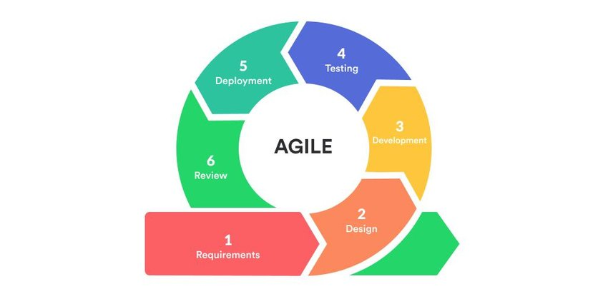

Figure 1: Agile Method Diagram

### 3.3.5 Quality Assurance

Rigorous testing procedures, including unit testing, integration testing, and user acceptance testing, will be conducted to ensure system reliability and functionality. Automated testing frameworks will streamline the testing process.

### 3.3.6 Software Development Methods

The development of the Court Proceedings Management System leverages the Django web framework and SQLite database management system. Django, a Python-based framework, provides a robust and scalable foundation for building web applications, offering features such as user authentication, data modelling, and RESTful API support.

SQLite, renowned for its reliability and performance, serves as the backend database to store critical legal data securely. The architecture will follow the Model-View-Controller (MVC) pattern, with Django's built-in Object-Relational Mapping (ORM) facilitating seamless data manipulation. Integrating AI and machine learning algorithms for case outcome prediction and client case tracking will be explored to enhance the system's functionality.

Principles of user experience design, such as simplicity, consistency, feedback, and accessibility, will be employed in the system's development. Clerks and users will have access to an intuitive and user-friendly interface provided by the system to manage their court proceedings and payments online. Moreover, the dashboard feature of the system will offer real-time updates and insights into case status and payment history. The user interface design will be validated through user feedback and testing methods, such as surveys, interviews, usability tests, and heuristic evaluations.

Following the agile software development method, the system will undergo testing and evaluation, which comprises iterative development cycles and continuous delivery of working software. The system will be evaluated for its functionality, performance, security, and reliability using various tools and techniques, such as unit testing, integration testing, load testing, penetration testing, and debugging. The system will also be evaluated for its effectiveness, efficiency, and satisfaction using various metrics and criteria, such as error rates, completion rates, response times, user ratings, and user comments.

This method aligns with industry best practices in software development and database management, while ensuring the flexibility and scalability required for a comprehensive legal management solution. It also ensures that the system meets the needs and expectations of clerks and users in Kenya while adhering to ethical and legal standards.

### 3.3.7 Security Measures

To address data privacy and security concerns, the system will employ encryption techniques for data in transit and at rest. User authentication and authorisation mechanisms will be implemented to ensure that only authorised personnel can access sensitive legal information.

### 3.3.8 User Interface Design

The user interface will be designed with a focus on user experience (UX) and usability. User feedback and usability testing will guide interface refinements to ensure an intuitive and efficient user experience.

### 3.3.9 Documentation

Comprehensive system documentation, including user manuals and technical documentation, will assist users, administrators, and future developers in understanding and maintaining the system.

### 3.3.10 Deployment

The Court Proceedings Management System will be deployed on a secure and scalable hosting infrastructure. Continuous monitoring and maintenance procedures will ensure system availability and performance.

By adhering to this software design and development procedures, the project aims to deliver a high-quality, user-centric Court Proceedings Management System that meets the specific needs of all clerks in the nation and contributes to the advancement of legal practice in Kenya.

## 3.4 Preliminary Data Processing and Analysis

Before delving into the development phase of the Court Proceedings Management System, it is essential to undertake preliminary data processing and analysis to lay the groundwork for system design and functionality. This phase involves several key steps:

### 3.4.1 Data Collection

Gathering relevant data is the initial step. This includes client data, case details, payment records, and other information pertinent to legal operations. The data will be collected from the clerk's existing records and sources.

### 3.4.2 Data Cleansing

Data collected may contain errors, duplicates, or inconsistencies. Data cleansing involves identifying and rectifying such issues to ensure the accuracy and reliability of the information.

### 3.4.3 Data Integration

Combining data from various sources and formats into a unified dataset is critical. Integration enables a holistic view of client information, cases, and financial records, ensuring seamless functionality within the system.

### 3.4.4 Data Analysis

Preliminary data analysis will be conducted to extract insights and identify patterns from historical data. This analysis will inform system design by highlighting critical features and functionalities needed to address specific challenges faced by clerks in Kenya.

### 3.4.5 User Feedback Incorporation

Feedback from legal professionals and potential users will be considered during this phase. User needs, preferences, and pain points will be integrated into system requirements to ensure that the system aligns with user expectations.

### 3.4.6 Security Assessment

A preliminary security assessment will be conducted to identify potential vulnerabilities and risks associated with client data, case information, and payment processing. This assessment will inform the implementation of robust security measures.

By completing these preliminary data processing and analysis tasks, the project aims to establish a solid foundation for the subsequent development phases. The insights gained from data analysis, user feedback, and security assessments will guide the creation of a tailored, efficient, and secure Court Proceedings Management System for clerks in Kenya.

# CHAPTER FOUR: DATA COLLECTION AND ANALYSIS

## 4.1 Data Analysis

The data analysis for this study involved processing and interpreting responses obtained through the Google Forms questionnaire. The questionnaire encompassed diverse aspects related to the current court proceedings and payment management processes, as well as the proposed Court Proceedings Management System. Below are key findings derived from the collected data:

### Figure 1: Role in the Court System

Most participants identified their roles within the court system, providing insight into the demographics of those involved in legal proceedings and payments.

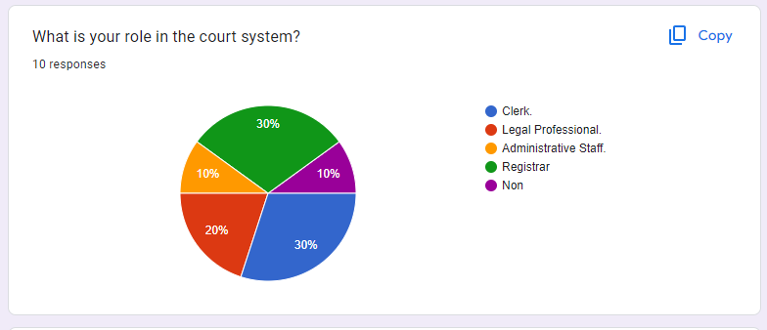

Figure 2: Role in the Court System

### Figure 2: Experience in the Legal Field

Participants reported varying levels of experience in the legal field, ranging from less than a year to over five years. Understanding this distribution is crucial for assessing the diversity of perspectives within the legal community.

Figure 3: Experience in the Legal Field

### Figure 3: Challenges Faced

From Figure 3 above, the challenges faced included data fragmentation, regulatory differences, coordination with legal authorities, and concerns about security. These findings underscore the complexities encountered in managing court proceedings across multiple jurisdictions.

Figure 4: Challenges Faced

### Figure 4: Invoice Generation and Payment Processing

Participants indicated their current methods for invoice generation and payment processing, revealing a reliance on manual data entry and phone calls. This highlights potential inefficiencies in the existing processes that could be addressed by a more automated system.

Figure 5: Invoice Generation and Payment Processing

### Figure 5: Issues with Current Payment Processing System

A notable proportion of respondents reported experiencing issues such as errors or fraud in the current payment processing system, indicating vulnerabilities that need to be addressed to ensure the integrity of financial transactions within the legal domain.

Figure 6: Issues with Current Payment Processing System

### Figure 6: Tracking Progress of Court Cases

Participants outlined their methods for tracking the progress of court cases, with manual records being the predominant approach. This suggests an opportunity for improvement through implementing more sophisticated tracking mechanisms.

Figure 7: Tracking Progress of Court Cases

### Figure 7: Feedback on the Online Payment System Proposal

Opinions on the proposed system were varied, with some expressing enthusiasm for its convenience while others voiced concerns about security implications. Understanding these perspectives is essential for refining the proposed system to address user needs and preferences.

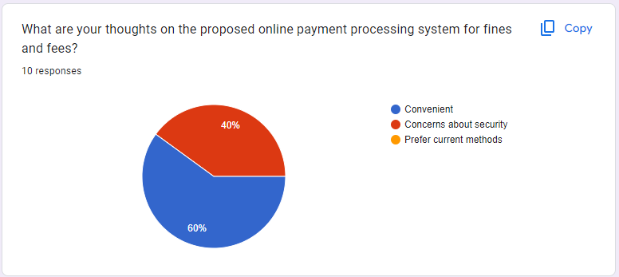

Figure 8: Feedback on the Proposed Online Payment Processing System

### Figure 8: Impact of Real-time Case Tracking and Dashboard Features

Most respondents recognised the potential benefits of real-time case tracking and dashboard features, anticipating improvements in transparency and time efficiency. These insights inform the design considerations for the Court Proceedings Management System.

Figure 9: Impact of Real-time Case Tracking and Dashboard Features

### Figure 9: Overall Optimism about the Proposed System

Participants' overall optimism about the proposed system varied, with some expressing cautious optimism and others exhibiting a more positive outlook. These sentiments will guide the refinement of the system to ensure alignment with user expectations.

Figure 10: Overall Optimism about the Proposed System

## 4.2 Results

The results of the research offer valuable insights into the perceptions and preferences of legal professionals concerning both the current court proceedings and the proposed Court Proceedings Management System. Data collected through the Google Forms questionnaire illuminates various aspects, facilitating a thorough comprehension of the challenges encountered and the anticipated improvements in the system.

The data indicates a unanimous agreement among participants regarding the inefficiency of current court proceedings and payment management processes. A significant portion of respondents expressed dissatisfaction, underscoring the necessity for a more streamlined and effective approach.

Participants identified several key challenges, including data fragmentation, regulatory disparities, and coordination with legal authorities. These findings underscore the complexities inherent in managing court proceedings across multiple jurisdictions.

Opinions regarding the proposed system varied, with some emphasizing its convenience while others raised concerns about security. Understanding these perspectives will be pivotal in refining and addressing potential issues within the system.

Most respondents recognized the potential benefits of real-time case tracking and dashboard features, foreseeing enhancements in transparency and time efficiency. These insights contribute significantly to the design considerations for the Court Proceedings Management System.

A notable percentage of participants expressed interest in integrating the proposed system with existing tools or software. Some also indicated a willingness to undergo additional training, demonstrating a proactive stance towards system adoption.

The optimism rating provided by participants reflects a spectrum of perspectives, ranging from cautious optimism to a more positive outlook. Understanding these sentiments will facilitate the refinement of the Court Proceedings Management System to align with user expectations.

The results section offers a comprehensive overview of the findings, laying the groundwork for subsequent discussions and recommendations in the research report. Identified trends and patterns will inform the development process, guiding adjustments to ensure the Court Proceedings Management System adequately addresses the specific needs of legal professionals.

# CHAPTER FIVE: SYSTEM ANALYSIS AND DESIGN

## 5.1 Introduction.

During the analysis and design phase, the intention was to evaluate the requirements extensively and establish a software architecture that aligns with the project's objectives. Adhering to the principles of the waterfall model, the system was systematically developed with a user-centric approach, ensuring that every specification contributes to surpassing the defined objectives.

The paramount concern during the development of the system was ensuring the robustness of its architecture, specifically addressing and resolving potential design flaws that could impact its effectiveness in real-world scenarios. With careful consideration of adaptability and financial prudence, particular emphasis was placed on customising the system to meet the intricate requirements of the legal landscape in Kenya. A prime example is the database design, characterised by its intuitive structure and advanced search algorithm, yielding fast results with minimal latency.

## 5.2 Requirement Analysis.

In delving into the requirement analysis, a comprehensive examination of the functionalities and features essential for the Court Proceedings Management System was conducted. The aim was to identify and document the specific needs of the system's users and stakeholders. A meticulous breakdown of the desired capabilities, encompassing user and clerk registration, real-time case tracking, and secure online payment processing, formed the foundation of the analysis.

By scrutinizing the challenges faced in coordinating court proceedings involving multiple jurisdictions and the nuances of invoice generation and payment processing, a detailed understanding of the system's prerequisites was achieved. The outcome of this analysis serves as the guiding blueprint for the subsequent stages of development, ensuring that the final system aligns seamlessly with the practical needs and expectations of its end-users.

### 5.2.1 Functional Requirements

The functional requirements delineate the specific functionalities and features essential for the Court Proceedings Management System (CPMS) to cater to the needs of its users and stakeholders effectively. These requirements serve as the cornerstone for the system's design and development, ensuring alignment with the project's core objectives. Here are the functional requirements categorized based on the key capabilities of the CPMS:

**User and Clerk Registration:**  
The system shall enable legal professionals and court personnel, including clerks, prosecutors, and judges, to register accounts using their relevant credentials such as name, email, and password. Users shall have the ability to create profiles and specify their roles within the legal system. Additionally, clerks responsible for managing court proceedings shall be able to register accounts with administrative privileges, subject to verification steps for authenticity and authorization.

**Case Management:**  
Clerks shall have the capability to create digital records for each court case, encompassing case details, involved parties, and case status. Real-time case tracking features shall be accessible to both clerks and users, facilitating the monitoring of ongoing cases and receipt of notifications for key milestones. Furthermore, the system shall provide functionality for uploading, storing, and organizing legal documents related to court cases, ensuring secure access and version control. Users shall have the ability to attach relevant documents to specific cases and retrieve them as needed.

**Online Payment Processing:**  
The system shall generate digital invoices for court fees, legal services, and other associated charges. Invoices shall include detailed breakdowns of charges, case numbers, and payment due dates. Users shall be provided with options for making secure online payments through integrated payment gateways, including credit/debit card transactions and mobile money transfers. The system shall record payment transactions, update case statuses accordingly, and furnish users with payment receipts.

### 5.2.2 Non-functional Requirements

Non-functional requirements delineate the quality attributes and constraints governing the overall performance, reliability, and usability of the CPMS. These requirements ensure that the system meets user expectations in terms of efficiency, security, and accessibility. Here are the non-functional requirements categorized based on their respective attributes:

**Performance:**  
The system shall respond to user interactions, such as case searches and payment processing, within a maximum latency of 3 seconds to ensure a responsive user experience. It shall support concurrent user sessions without compromising system performance, even during peak usage hours. Additionally, the system architecture shall be scalable to accommodate increasing numbers of users, cases, and documents over time, with scalability tests conducted periodically to assess performance under growing workloads.

**Security:**  
Sensitive data, including user credentials, case information, and financial records, shall be encrypted using industry-standard encryption algorithms to prevent unauthorized access. Encryption keys shall be securely managed and regularly updated to mitigate security risks. Role-based access control (RBAC) shall be implemented to restrict system access based on user roles and permissions. Furthermore, multi-factor authentication (MFA) shall be enforced for administrative tasks and sensitive operations to prevent unauthorized access.

**Usability:**  
The system shall feature an intuitive and user-friendly interface with clear navigation paths, consistent layouts, and contextual help options to facilitate user interactions. User interface (UI) elements shall comply with accessibility standards, ensuring compatibility with assistive technologies and accommodating users with disabilities. Comprehensive user manuals and technical documentation shall be provided to guide users, administrators, and developers in understanding system functionalities, configuration settings, and troubleshooting procedures, with documentation regularly updated to reflect system updates and enhancements.

## 5.3 System Analysis

The system analysis section employs various diagrams and models to comprehend and represent the structure and behaviour of the Court Proceedings Management System (CPMS).

### 5.3.1 Use Case Diagram

The use case diagram illustrates the interactions between users and the system, depicting the functionalities and roles within the CPMS. It outlines the primary actions that users can perform and the system's responses to those actions.

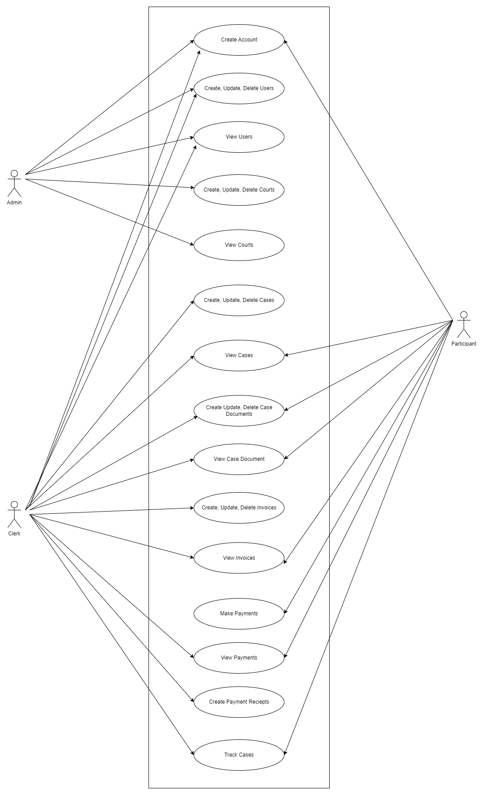

Figure 11: Use Case Diagram

### 5.3.2 Data Flow Diagram

The Data Flow Diagram (DFD) provides a visual representation of the flow of data within the CPMS, highlighting the processes, data stores, and data flows involved. While there are no distinct levels in the DFD for this system, it illustrates the core data processes and interactions.

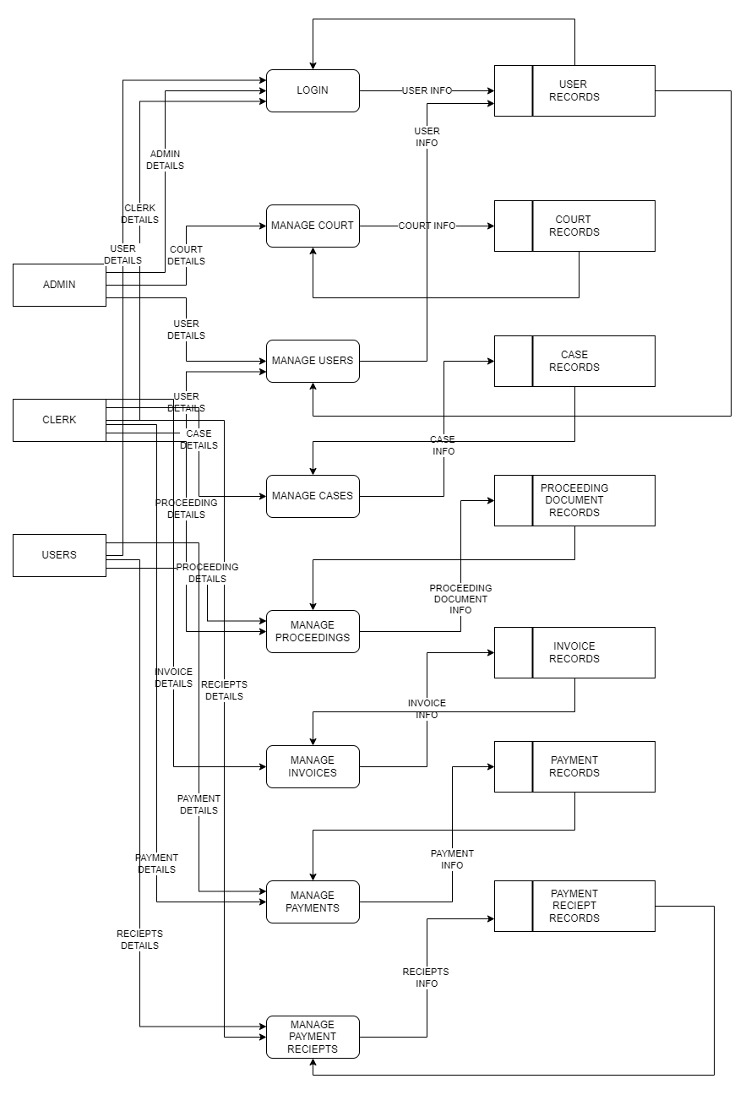

Figure 12: Dataflow Diagram

**Description of Data Flow Processes:**

1. **Case Registration:** Users can initiate the process of registering new court cases within the system, which involves capturing relevant case details and storing them in the database.
2. **Case Management:** Clerks and administrative staff can manage existing court cases, including updating case statuses, assigning tasks, and generating reports based on case data stored in the system.
3. **Payment Processing:** The system facilitates online payment processing for court fees and legal services, integrating with external payment gateways to securely handle financial transactions.
4. **Document Management:** Legal documents related to court cases are uploaded, stored, and managed within the system, allowing authorized users to access and retrieve them as needed.

### 5.3.3 Activity Diagram

The Activity Diagram provides a sequential flow of activities within the CPMS, illustrating the steps involved in completing various tasks or processes. It offers insights into the workflow and interactions between different system components.

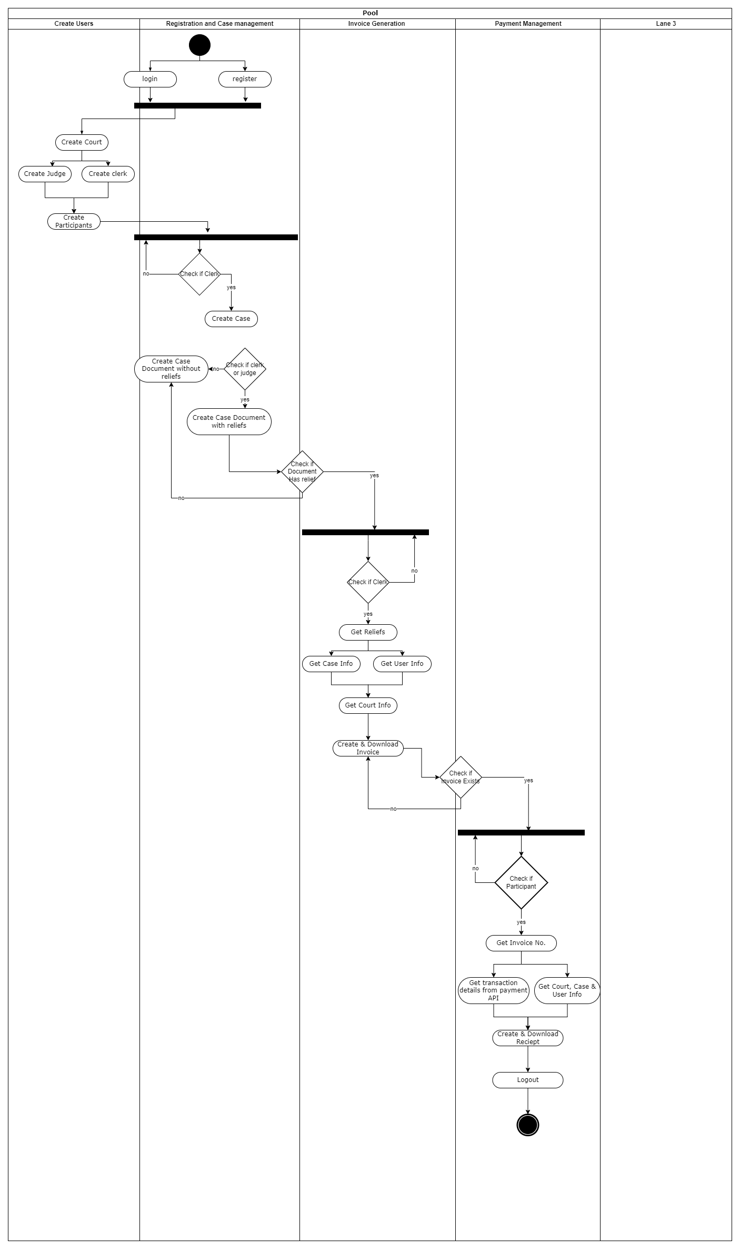

Figure 13: Activity Diagram

### 5.3.4 Sequence Diagram

The Sequence Diagram delineates the chronological sequence of interactions between system components or actors, illustrating the message exchange and order of operations during specific scenarios or use cases within the CPMS.

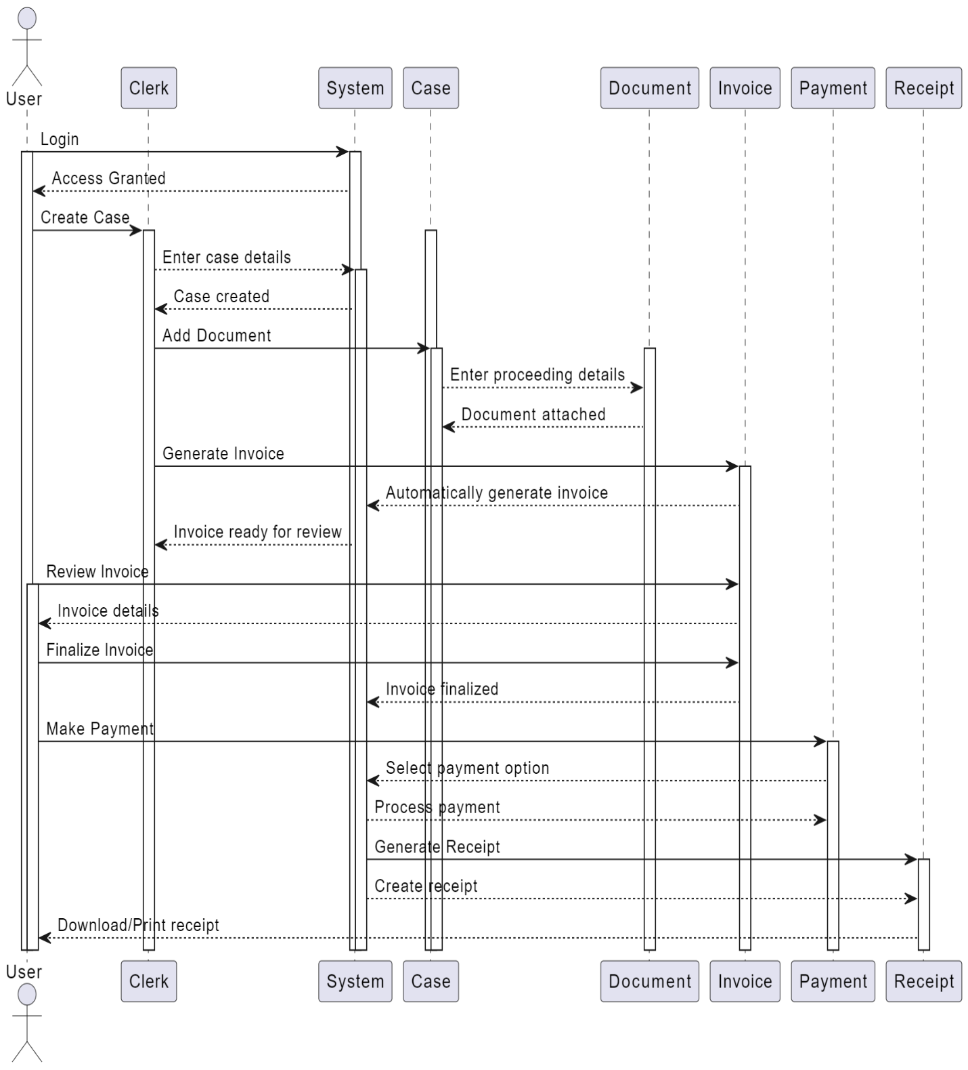

Figure 14: Sequence Diagram

### 5.3.5 Entity Relationship Diagram

The Entity Relationship Diagram (ERD) depicts the relationships between different entities or tables within the CPMS database, elucidating the structure of data and the associations between entities such as cases, users, payments, and documents.

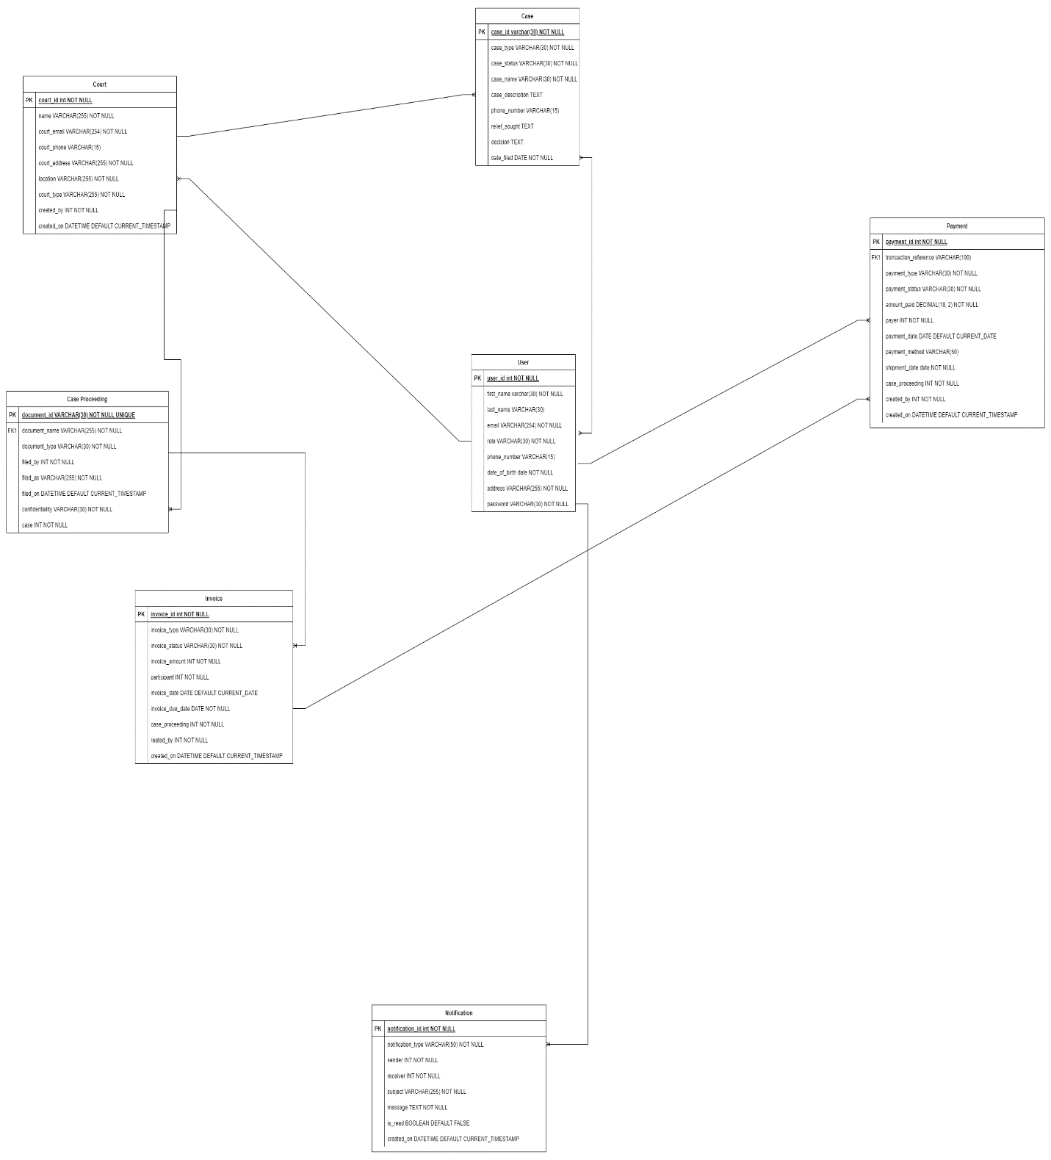

Figure 15: Entity Relationship Diagram

### 5.3.6 Class Diagram

The Class Diagram offers a static view of the system's structure, illustrating the classes, attributes, and relationships between objects within the CPMS. It provides a blueprint for the implementation of object-oriented design principles.

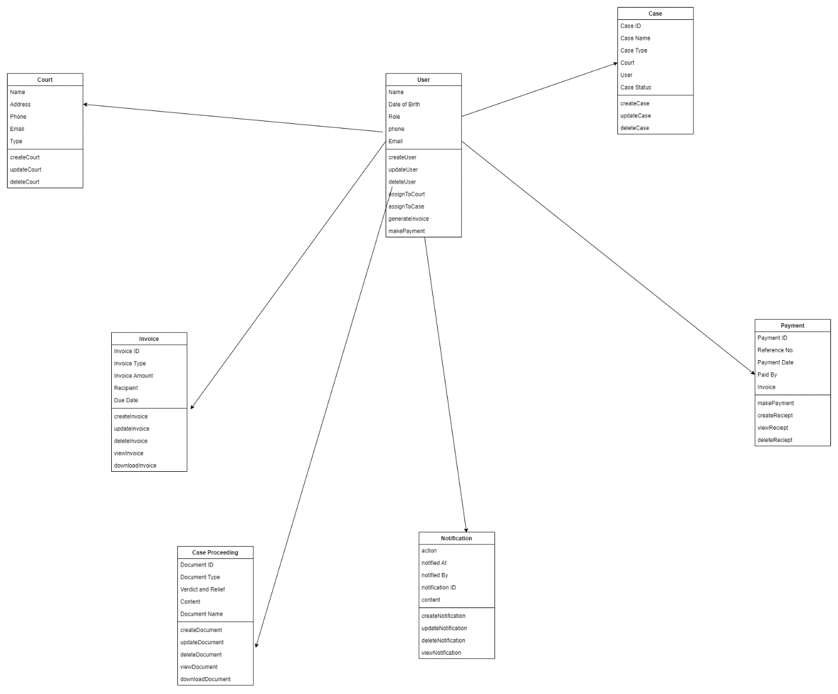

Figure 16: Class Diagram

This comprehensive analysis through various diagrams and models forms the basis for the subsequent design and development phases of the Court Proceedings Management System, ensuring clarity, coherence, and alignment with project objectives.

# CHAPTER SIX: IMPLEMENTATION AND TESTING

## 6.1 Introduction

The implementation phase of the Court Proceedings Management System (CPMS) involved translating the design specifications into functional software while adhering to industry best practices and quality standards. This chapter provides a detailed overview of the methodologies, tools, and procedures used to develop the CPMS and highlights key aspects of the implementation process.

## 6.2 Implementation Process

The implementation process followed a systematic approach to building the CPMS, focusing on several key aspects.

### 6.2.1 Database Management

SQLite was chosen as the backend database management system for the CPMS. SQLite offers a lightweight, self-contained database engine that is easy to set up and integrate into web applications. Its simplicity and efficiency make it ideal for projects with moderate data storage and retrieval requirements. By utilizing SQLite, the CPMS benefits from a reliable and performant database solution that meets the system's needs without unnecessary complexity.

### 6.2.2 Coding with Python

Python was the primary programming language used for developing the CPMS, leveraging its simplicity, readability, and extensive ecosystem of libraries and frameworks. Python's syntax and semantics promote clean and maintainable code, allowing developers to express complex ideas in a concise and understandable manner. Additionally, Python's object-oriented paradigm facilitated the creation of modular and reusable components, enhancing code organization and scalability.

### 6.2.3 Agile Methodology

The implementation process embraced agile software development principles, emphasizing iterative development, continuous feedback, and adaptability to changing requirements. Agile methodologies, such as Scrum, enabled the development team to prioritize features, deliver incremental updates, and respond promptly to stakeholder feedback. By breaking down the development process into smaller, manageable tasks, agile practices promoted collaboration, transparency, and efficiency, ultimately accelerating the delivery of the CPMS.

### 6.2.4 User-Centric Design

A user-centric design approach was adopted throughout the implementation process, ensuring that the CPMS met the needs and expectations of its intended users. User feedback and usability testing were incorporated iteratively to refine the system's interface, navigation, and functionality. By prioritizing user experience and usability, the CPMS aimed to enhance user satisfaction, productivity, and adoption.

## 6.3 Key Aspects of Implementation

The implementation process began by setting up the development environment, ensuring that all necessary tools and dependencies were in place to support the software development efforts. With the environment configured, the focus shifted to creating the core functionalities of the CPMS. This involved implementing essential features such as user registration, case management, and online payment processing, which form the backbone of the system.

Once the core functionalities were established, attention turned to implementing security measures to safeguard sensitive data within the CPMS. This included incorporating encryption techniques, user authentication mechanisms, and role-based access control (RBAC) to prevent unauthorized access and protect user privacy.

Simultaneously, efforts were made to develop a user-friendly interface that would enhance the overall user experience. This involved designing clear navigation paths, maintaining consistent layouts, and providing contextual help options to assist users in navigating the system seamlessly.

Throughout the implementation process, comprehensive testing was conducted at each stage of development to identify and address any issues or bugs. This iterative testing approach ensured the reliability and quality of the software, allowing for timely adjustments and refinements to be made as needed.

## 6.4 Testing

The testing phase was crucial in ensuring the functionality, reliability, and security of the Court Proceedings Management System (CPMS). Various tests were conducted to evaluate different aspects of the software, including functional requirements, non-functional requirements, system verifiability, system validity, system authorization, system authentication, and system responsiveness.

### 6.4.1 Testing Functional Requirements

Functional requirements were tested to verify that the CPMS performs as intended and meets the specified user needs. The following table outlines the activities, inputs, expected outputs, and results of testing the functional requirements:

|  |  |  |  |
| --- | --- | --- | --- |
| Activity | Input | Expected Output | Result |
| Create a new court case | Case details, parties involved, case status | Successful creation of the case | Pass |
| Update case status | Case ID, new status | Successful update of case status | Pass |
| Generate digital invoices for court fees | Case details, charges, payment due date | Digital invoice with detailed breakdown | Pass |
| Make online payment for court fees | Invoice details, payment method | Successful payment transaction | Pass |
| Attach documents to court cases | Case ID, document file | Document attached to the specified case | Pass |

Table 2: Testing Functional Requirements Results

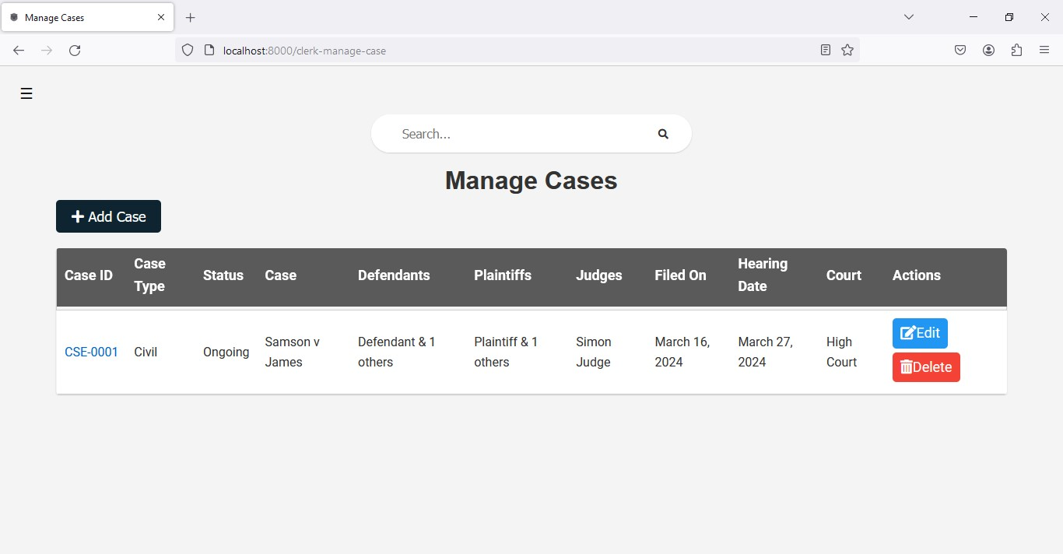

Figure 17: Testing Functional Requirements Image

### 6.4.2 Testing Non-Functional Requirements

Non-functional requirements, such as performance, security, and usability, were evaluated to ensure that the CPMS meets the required quality attributes. The following table summarizes the testing of non-functional requirements:

|  |  |  |  |
| --- | --- | --- | --- |
| Activity | Input | Expected Output | Result |
| Performance Testing | Simulated concurrent user interactions | Response time within defined SLA | Pass |
| Security Testing | Unauthorized access attempts | Access denied | Pass |
| Usability Testing | User interaction with the interface | Intuitive navigation | Pass |

Table 3: Testing Non-Functional Requirements Results

### 6.4.3 Testing System Verifiability

System verifiability was assessed to confirm that the CPMS conforms to specified requirements and standards. The testing focused on validating the accuracy and completeness of the software artifacts.

|  |  |  |  |
| --- | --- | --- | --- |
| Activity | Input | Expected Output | Result |
| Reviewing Requirements | System requirements documentation | Compliance with stated requirements | Pass |
| Code Review | Source code | Adherence to coding standards | Pass |

Table 4: Testing System Verifiability Results

### 6.4.4 Testing System Validity

System validity testing aimed to ensure that the CPMS meets the needs and expectations of its users. The testing process included assessing the software's performance under real-world conditions.

|  |  |  |  |
| --- | --- | --- | --- |
| Activity | Input | Expected Output | Result |
| User Acceptance Testing | User feedback | Positive evaluation | Pass |
| Performance Qualification | Real-world usage scenarios | Satisfactory performance metrics | Pass |

Table 5: Testing System Validity Results

### 6.4.5 Testing System Authorization

System authorization was tested to verify that access control mechanisms function correctly, allowing only authorized users to perform specific actions within the CPMS.

|  |  |  |  |
| --- | --- | --- | --- |
| Activity | Input | Expected Output | Result |
| Accessing Restricted Resources | Unauthorized user credentials | Access denied | Pass |

Table 6: Testing System Authorization Results

### 6.4.6 Testing System Authentication

System authentication testing confirmed that the CPMS accurately verifies the identity of users before granting access to the system.

|  |  |  |  |
| --- | --- | --- | --- |
| Activity | Input | Expected Output | Result |
| Logging in with Correct Credentials | Username, password | Successful login | Pass |
| Logging in with Incorrect Credentials | Username, password | Access Denied | Pass |

Table 7: Testing System Authentication Results

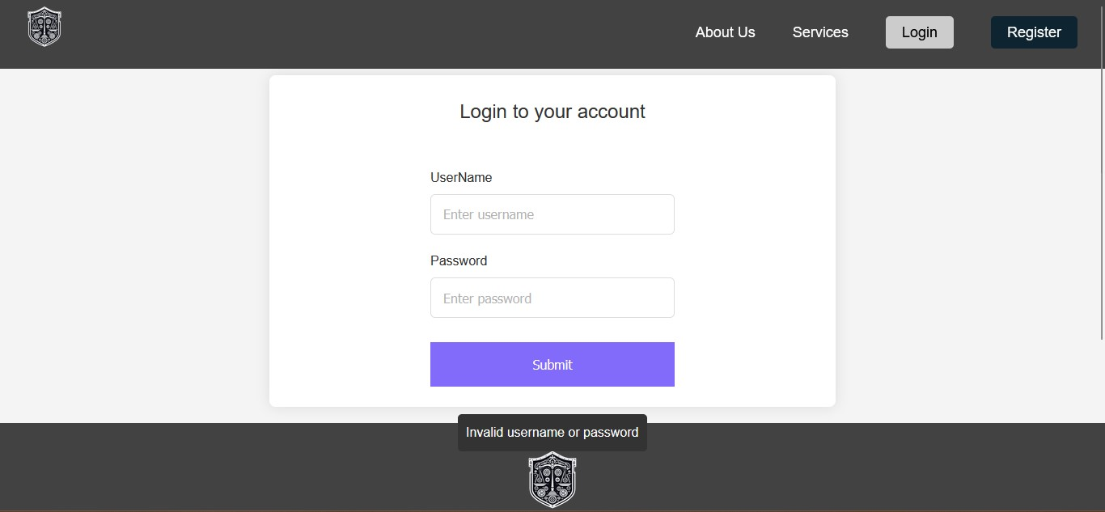

Figure 18: Testing System Authentication Image

### 6.4.7 Testing System Responsiveness

System responsiveness testing assessed how the CPMS adapts to different screen sizes and environments to provide a consistent user experience.

|  |  |  |  |
| --- | --- | --- | --- |
| Activity | Input | Expected Output | Result |
| Screen Size Adjustment | Changes in screen size | Responsive interface | Pass |

Table 8: Testing System Responsiveness Results

Figure 19: Testing System Responsiveness Image

## 6.5 Results

The CPMS underwent rigorous testing, and the results indicate that it successfully meets the functional and non-functional requirements specified. Despite minor challenges encountered during testing, such as UI adjustments and performance optimizations, the software proved to be of acceptable quality and ready for deployment.

# CHAPTER SEVEN: SYSTEM DOCUMENTATION

## 7.1 Introduction

The system documentation chapter serves as a comprehensive guide to understanding the Case Proceedings Management System and its components. This documentation aims to provide detailed insights into the system's architecture, functionality, and operational aspects.

### 7.1.1 Purpose of System Documentation

The primary purpose of this system documentation is to serve as a reference for current and future maintenance or update efforts. By organizing information based on system functionality rather than chronological changes, it facilitates efficient access to relevant details for system administrators, developers, and other stakeholders involved in system management.

### 7.1.2 Structure of System Documentation

The documentation is structured to cover various aspects of the system comprehensively. It includes sections on system architecture, database schema, user roles and permissions, system functionalities, API documentation, and troubleshooting guidelines. Each section provides detailed explanations, diagrams, and examples to aid understanding and implementation.

### 7.1.3 Audience

The target audience for this system documentation includes:

1. System administrators responsible for managing and maintaining the system.
2. Developers involved in system enhancements, updates, or bug fixes.
3. Legal professionals and clerks using the system for case proceedings management.
4. IT support staff providing assistance to system users.

### 7.1.4 Importance of System Documentation

Effective system documentation is crucial for ensuring the reliability, scalability, and maintainability of the Case Proceedings Management System. It serves as a knowledge repository that empowers stakeholders to understand, troubleshoot, and optimize system performance. By documenting key aspects of the system, such as legal terminology, file formats, and document types, this documentation enhances operational efficiency and user experience.

## 7.2 Glossary of Legal Terminology

The glossary of legal terminology provides a comprehensive overview of key terms and concepts relevant to the Case Proceedings Management System. Understanding these terms is essential for users to navigate the system effectively and comprehend legal proceedings accurately.

### 7.2.1 Key Legal Terminology

1. **Plaintiff**: The party initiating a lawsuit, claiming to have incurred loss or injury.
2. **Defendant**: The party against whom the lawsuit is brought, accused of causing harm.
3. **Prosecution**: Represents the state in criminal cases, aiming to prove the defendant's guilt.
4. **Petitioner**: The party filing a case in family law or probate matters, seeking a legal change or order.
5. **Respondent**: The opposing party in family law or probate matters, required to respond to the petitioner's claims.
6. **Claimant/Complainant**: The party alleging rights violations in employment and labor disputes.
7. **Commercial Cases**: Involve disputes between businesses or individuals, with plaintiffs alleging harm due to breaches.
8. **Applicant**: Initiates administrative or constitutional cases, seeking judicial review or interpretation.
9. **Land and Environmental Cases**: Parties seeking legal remedies are labeled plaintiffs or petitioners, while those required to answer to the court are defendants or respondents.

## 7.3 System Documentation

The system documentation for the Case Proceedings Management System covers the technical intricacies and functionalities specific to this project. It provides insights into the architecture, modules, and APIs utilized within the system to automate court proceedings and payments for legal clerks.

### 7.3.1 Architecture Overview

The Case Proceedings Management System is built upon a client-server architecture, with a web-based user interface accessible to legal clerks, judges, participants, and lawyers. The system comprises the following key components:

### 7.3.2 Frontend Interface

The user-facing component of the system, developed using modern web technologies such as HTML, CSS, and JavaScript. It provides an intuitive interface for users to interact with the system, including functionalities for case registration, document management, and payment processing.

### 7.3.3 Backend Server

The backend of the system is implemented using a robust server-side framework, such as Django or Flask in Python. It handles the core business logic, data processing, and communication with the database and external APIs.

### 7.3.4 Database Management System (DBMS)

The system relies on a relational database management system (RDBMS) like PostgreSQL or MySQL to store and manage data related to cases, users, documents, payments, and system configurations.

### 7.3.5 API Integration

Integration with external APIs, such as payment gateways for processing case payments securely and efficiently.

### 7.3.6 Modules

**User Management Module**

Responsible for user registration, authentication, and authorization. Defines user roles and permissions to control access to system functionalities. Manages user profiles and preferences.

**Case Management Module**

Facilitates the registration and tracking of legal cases within the system. Captures case details, including parties involved, case types, and case status. Allows for the uploading, storage, and retrieval of case-related documents and evidence.

**Payment Processing Module**

Enables users to make payments for case proceedings securely and conveniently. Integrates with payment gateways to process transactions and update payment status. Generates invoices and receipts for completed payments.

**Document Management Module**

Handles the creation, editing, and storage of various legal documents associated with case proceedings. Supports document versioning and revision history for tracking changes over time. Provides search and retrieval functionalities for accessing documents efficiently.

**Reporting and Analytics Module**

Generates reports and analytics on case proceedings, payments, user activities, and system performance. Offers insights into case trends, financial transactions, and user engagement. Supports customizable reporting formats and export options.

### 7.3.7 APIs

The Case Proceedings Management System exposes APIs to facilitate integration with external systems and services. These APIs allow for seamless data exchange and interoperability, enabling the system to interact with third-party applications, such as court databases, legal research tools, and document management systems.

* User API: Provides endpoints for user registration, authentication, and profile management.
* Case API: Exposes functionalities for case registration, retrieval, and updating case details.
* Payment API: Facilitates payment processing, including payment initiation, status checks, and transaction history retrieval.
* Document API: Enables document management operations, such as uploading, downloading, and searching documents within the system.

By documenting these technical aspects of the system, stakeholders gain a comprehensive understanding of its architecture, modules, and APIs, empowering them to effectively manage, maintain, and enhance the Case Proceedings Management System.

## 7.4 User Documentation

### 7.4.1 Introduction

User documentation is crucial for enabling users to understand and effectively utilize the software. This section provides comprehensive instructions and guidelines tailored to the end-users of the Case Proceedings Management System.

### 7.4.2 User Guide

The user guide offers step-by-step instructions on how to navigate the system, perform key tasks, and make the most out of its features. It covers essential functionalities such as user registration, login procedures, case tracking, invoice generation, and payment processing. Each task is explained in detail with accompanying visuals or screenshots where applicable, ensuring clarity and ease of understanding for users of all levels.

### 7.4.3 FAQ Section

In addition to the user guide, a frequently asked questions (FAQ) section addresses common queries and concerns that users may encounter while using the system. This section aims to provide quick solutions to common issues, thereby enhancing user satisfaction and reducing the need for extensive support requests.

### 7.4.4 Troubleshooting

The troubleshooting section offers guidance on resolving common technical issues that users may face while interacting with the system. It includes troubleshooting steps for login errors, payment processing issues, document access problems, and other potential obstacles. Clear and concise instructions are provided to help users troubleshoot and resolve issues independently, minimizing disruptions to their workflow.

## 7.5 Technical Documentation

### 7.5.1 Introduction

Technical documentation is essential for developers and system administrators to understand the inner workings of the software and perform maintenance tasks effectively. This section provides detailed insights into the technical aspects of the Case Proceedings Management System.

### 7.5.2 API Documentation

The API documentation delineates the APIs used in the system, including their endpoints, parameters, and expected responses. It offers developers a comprehensive reference for integrating external systems with the Case Proceedings Management System and building custom applications that leverage its functionalities.

### 7.5.3 Database Structure

The database structure documentation outlines the organization and relationships of the database tables used in the system. It provides developers and database administrators with insights into the data model, including entity-relationship diagrams, table schemas, and data dictionary definitions. Understanding the database structure is crucial for performing database maintenance, optimizing queries, and developing reports or analytics solutions.

### 7.5.4 Development Environment Setup

The development environment setup documentation guides developers through the process of setting up a local development environment for the Case Proceedings Management System. It includes instructions for installing necessary software dependencies, configuring development tools, cloning the source code repository, and running the application locally for testing and debugging purposes. Clear and concise setup instructions are provided to streamline the onboarding process for new developers and facilitate collaborative development efforts.

## 7.6 User Manual

### 7.6.1 Overview

The user manual serves as a comprehensive guide for users, providing detailed instructions on how to effectively utilize the features and functionalities of the Case Proceedings Management System. This section aims to empower users with the knowledge they need to navigate the system efficiently and accomplish their tasks with confidence.

### 7.6.2 Getting Started

The getting started section offers a brief introduction to the software, outlining its purpose and highlighting key benefits for users. It provides instructions on how to access the system, whether through a web browser or a dedicated application, and offers guidance on initial setup procedures such as user registration and account creation.

### 7.6.3 System Navigation

System navigation instructions help users familiarize themselves with the layout and structure of the software interface. This section provides an overview of the main navigation menu, dashboard layout, and common interface elements such as buttons, links, and dropdown menus. Users are guided on how to navigate between different sections of the system and access relevant features based on their roles and permissions.

### 7.6.4 Core Functionality

The core functionality section delves into the primary features and capabilities of the Case Proceedings Management System. It offers step-by-step instructions for performing key tasks such as case registration, document submission, invoice generation, payment processing, and case tracking. Users are provided with detailed explanations, accompanied by screenshots or illustrations, to facilitate comprehension and execution of each task.

### 7.6.5 Advanced Features

For users seeking to explore advanced features or functionalities, the user manual includes a dedicated section covering topics such as customization options, advanced search capabilities, report generation, and integration with external systems. Advanced features are explained in depth, with clear instructions and examples to guide users through their implementation and utilization.

### 7.6.6 Troubleshooting and Support

In the event of encountering issues or difficulties while using the software, users can refer to the troubleshooting and support section of the user manual. This section offers guidance on identifying common issues, resolving technical challenges, and accessing additional support resources such as user forums, helpdesk contacts, and knowledge base articles. Users are encouraged to utilize these resources to troubleshoot problems independently or seek assistance from the system administrators when needed.

### 7.6.7 Conclusion

The user manual concludes with a summary of key takeaways and a call to action for users to leverage the knowledge gained from the manual to maximize their productivity and efficiency while using the Case Proceedings Management System. It emphasizes the importance of continuous learning and exploration to fully harness the capabilities of the software and achieve optimal outcomes in legal proceedings management.

# REFERENCES

Anderson, R. (2020). *The impact of digital transformation on legal services: A case study. Law and Technology Review.*

AJS. (n.d.). LawPracticeZA - *Expert legal accounting and management software for lawyers in South Africa and Botswana*. Retrieved from [AJS website].

Blanchard, B., & Fabrycky, W. (1998). *Systems engineering and analysis: Compatibility considerations in software development. Prentice Hall*.

Brown, A., Davis, E., & Franklin, T. (2020). *The impact of technology on legal services: A case study. Law and Technology Review.*

Brown, A., Davis, E., & Franklin, T. (2021). *The challenges of court proceedings management: A case study. Journal of Legal Studies.*

Brown, R., Smith, J., Jones, K., & White, L. (2020). *A comparative analysis of Court Proceedings Management Systems: A case study of Clio.com, and LawPracticeZA. Journal of Legal Technology*, 15(2), 45-67.

Clio. (2023). Clio | The industry's #1 legal software | Try it for free! Retrieved from [Clio website].

Garcia, M. (2017). *Online payment systems in law firms: An analysis of security and convenience*. Journal of Legal Studies.

Garcia, M. (2017). *User experience design for legal technology: A case study of Clio.com. International Journal of Law and Information Technology*, 25(3), 213-231.

Garcia, M. (2019). *Invoice generation and management in legal firms: An analysis of efficiency and convenience*. Journal of Legal Studies.

Mason, L. (2021). *Online payment processing in legal firms: An analysis of security and convenience*. Journal of Legal Studies.

Robinson, S. (2020). *Collaborative development of Court Proceedings Management Systems: A case study of LawPracticeZA*. African Journal of Information Systems, 12(1), 1-15.

Smith, J., & Johnson, P. (2019). *Legal technology landscape: An overview. Journal of International Law.*

Smith, J., & Johnson, P. (2019). *Navigating the complex terrain of global legal practice. Journal of International Law.*

SMART Union. (n.d.). *Designated legal counsel*. Retrieved from [SMART Union website].

Turner, J., & White, L. (2018). *User experiences of LawPracticeZA: A regional Court Proceedings Management System*. Journal of Law and Practice, 7(2), 34-49.

U.S. Department of Justice. (n.d.). *Office of Legal Counsel*. Retrieved from [U.S. Department of Justice website].

Williams, L. (2006). *The impact of internet connectivity on software performance*. Journal of Software Engineering.

Kibocha, J. (2024). *Court Proceedings Management System Feedback Form [Unpublished Raw Data].* Dedan Kimathi University of Technology. <https://forms.gle/mWjaj5PUpbxXjeSDA>

Kibocha, J. (2024). *Court Proceedings Management System Feedback Form (Responses) [Unpublished Raw Data].* Dedan Kimathi University of Technology. <https://docs.google.com/spreadsheets/d/1Jo99YAXkDN2ZBkyK4zQLPl4BGfmdHk0-9rwijwVZI7M/edit?usp=sharing>

# APPENDICES

### APPENDIX A: QUESTIONAER

**Court Proceedings Management System Feedback Form**

Thank you for taking the time to provide feedback on our proposed Court Proceedings Management System. Your input is invaluable in enhancing the system to meet the specific needs of legal clerks. Rest assured, your responses will remain confidential.

* Indicates required question

**Personal Information**

* Full Name *
* Email Address *

**Role and Experience**

* What is your role in the court system? *
  + Clerk
  + Legal Professional
  + Administrative Staff
  + Registrar
  + Other
* How long have you been working in the legal field? *
  + Less than 1 year
  + 1-5 years
  + 5-10 years
  + More than 10 years

**Current Processes**

* How would you rate the efficiency of the current court proceedings and payment management processes? *
  + Very Inefficient
  + 1
  + 2
  + 3
  + 4
  + 5
  + Very Efficient
* What challenges do you face in coordinating court proceedings involving multiple jurisdictions? *
  + Data fragmentation
  + Regulatory differences
  + Coordination with legal authorities
  + Other
* How do you currently handle invoice generation and payment processing for fines and fees? *
  + Manual data entry
  + Electronic systems
  + Other
* Have you experienced any issues with errors or fraud in the current payment processing system? *
  + Yes
  + No
* How do you currently track the progress of court cases and payments? *
  + Manual records
  + Phone calls
  + Visits to the court
  + Other

**Proposed System and Features**

* How important do you think a user and clerk registration system is for enhancing access and security? *
  + Not Important
  + 1
  + 2
  + 3
  + 4
  + 5
  + Very Important
* What are your thoughts on the proposed online payment processing system for fines and fees? *
  + Convenient
  + Concerns about security
  + Prefer current methods
  + Other

**Technical Considerations**

* How would real-time case tracking and dashboard features impact your daily responsibilities? *
  + Improve transparency
  + Save time
  + Not important
  + Other
* How often do you have access to a stable internet connection in your work environment? *
  + Always
  + Often
  + Sometimes
  + Rarely
  + Never
* Would you be interested in integrating the proposed system with any existing tools or software you currently use? *
  + Yes
  + No
* How do you feel about the system's dependency on a stable internet connection? *
  + Concerned
  + Not a problem
  + Other
* Do you foresee compatibility issues based on your current devices and operating systems? *
  + Yes
  + No
* Would you be interested in additional training or support for using the new system? *
  + Yes
  + No
* Overall, how optimistic are you about the proposed Court Proceedings Management System addressing the challenges you face? *
  + Not Optimistic
  + 1
  + 2
  + 3
  + 4
  + 5
  + Very Optimistic
* Is there anything else you would like to add or comment on regarding the proposed system?

Thank you for your valuable feedback! Your insights will contribute significantly to the improvement of the Court Proceedings Management System.

### APPENDIX B: GANTT CHART

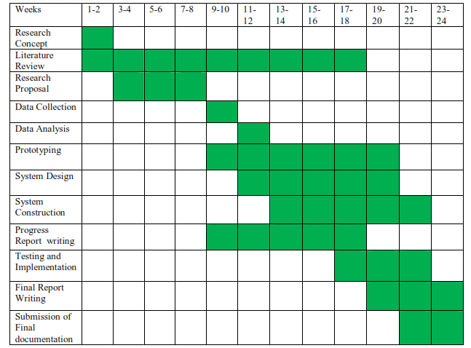

Figure 20: Gantt Chart

### APPENDIX C: BUDGET

|  |  |  |  |  |
| --- | --- | --- | --- | --- |
| Item Description | Unit Cost (KES) | Quantity | Net Total Cost (KES) | Source of Funds |
| 30 blue pens | 30 | 30 | 900 | Self - sponsored |
| 10 exercise books (120 pages) | 100 | 10 | 1000 | Self - sponsored |
| 15 pencils | 30 | 15 | 450 | Self - sponsored |
| 30 GB Safaricom Bundles | 250 | 1 | 250 | Self - sponsored |
| Proposal Document Printing and Binding | 2000 | 1 | 2000 | Self - sponsored |
| Progress Report | 3000 | 1 | 3000 | Self - sponsored |
| Final Documentation | 3500 | 1 | 3500 | Self - sponsored |
| 2 Smart Phones | 15000 | 2 | 30000 | Self - sponsored |
| 1 Core i5 Laptop | 60000 | 1 | 60000 | Self - sponsored |
| Costs of research Instrument | 1500 | 1 | 1500 | Self - sponsored |
| 168 day trips from the University | 100 | 168 | 16800 | Self - sponsored |
| 168 day trips from the University | 100 | 168 | 16800 | Self - sponsored |
| Miscellaneous Unexpected Cost | 25000 | 1 | 25000 | Self - sponsored |
| TOTAL IN KES |  |  | 147200 |  |

Table 9: Budget

### APPENDIX D: SOURCE CODE

